**ME 227 Final Project Report**

**Spring 2019**

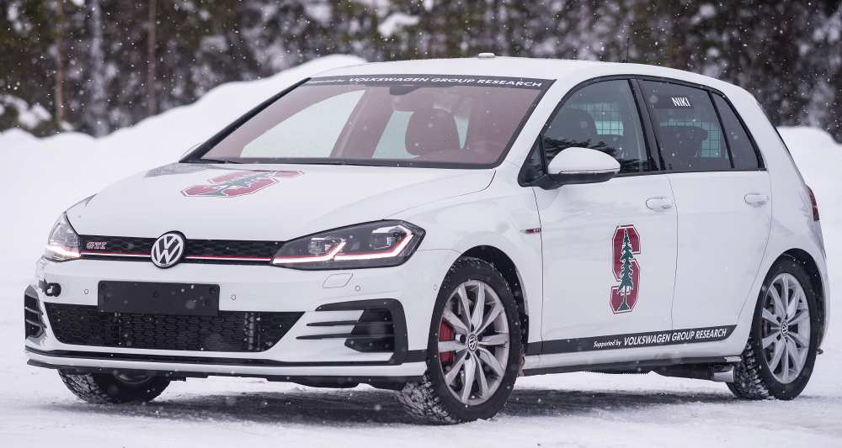

Team Autobug

Team #7

Adit Desai

Ashar Alam

Kshitij Kumbar

Picture courtesy: Zhang, Vivian. “Vehicle Dynamics and Control At The Limits of Handling.” *Vehicle Dynamics and Control At The Limits of Handling | Dynamic Design Lab*, ddl.stanford.edu/publication-research-theme/vehicle-dynamics-and-control-limits-handling.

Picture courtesy: Zhang, Vivian. “Vehicle Dynamics and Control At The Limits of Handling.” *Vehicle Dynamics and Control At The Limits of Handling | Dynamic Design Lab*, ddl.stanford.edu/publication-research-theme/vehicle-dynamics-and-control-limits-handling.

Picture courtesy: Zhang, Vivian. “Vehicle Dynamics and Control At The Limits of Handling.” | Dynamic Design Lab, ddl.stanford.edu/publication-research-theme/vehicle-dynamics-and-control-limits-handling.

**1. Description of controllers**

**Look Ahead Controller**

This controller uses the standard formulation for the a lateral controller based on the heading error at a certain look ahead distance and gain. The controller is formulated as follows

Where is the steering angle control signal, is the lateral error, is the heading error, is the front cornering stiffness, is lookahead distance and is look ahead gain. Apart from the controller working on the feedback terms, the controller also uses a feedforward term to augment the steering angle output. This feed forward term is formulated as follows:

Where are distances from the center of gravity of car to the front and rear ends respectively, is the rear cornering stiffness, is mass of the car, is the road curvature, is the vehicle wheelbase, is the understeer gradient andis the longitudinal velocity.

**LQR mean based controller**

The second controller being used is a Linear Quadratic Regulator(LQR) based controller which provides a steering angle based on the error in observed states using the following formulation :

Where is the lateral error and its derivative and is the heading error and its derivative.The gain is selected such that it minimizes the quadratic cost function

Where represents discrete error states,represents discrete steering angle signals and represent the weighting matrices for the error states and control output respectively, subject to the same system dynamics used for the lookahead. As the system matrices are dependent on longitudinal velocity, these gains change with each time step with change in observed longitudinal velocity. Hence mean values of each of the overall observed gain values is considered as the static set of gains to operate the controller. Like the lookahead controller, the LQR based controller also uses feedforward terms to augment the steering angle output. This feed forward term is formulated as follows:

**Longitudinal Controller**

To maintain the desired acceleration and velocity on the desired trajectory while compensating for the drag and rolling resistance that the car experiences, the following longitudinal controller was used:

Where is the commanded longitudinal force, are the desired longitudinal acceleration and velocity, is the rolling resistance, is aerodynamic drag on the car.

**2. Desired Velocity and Acceleration**

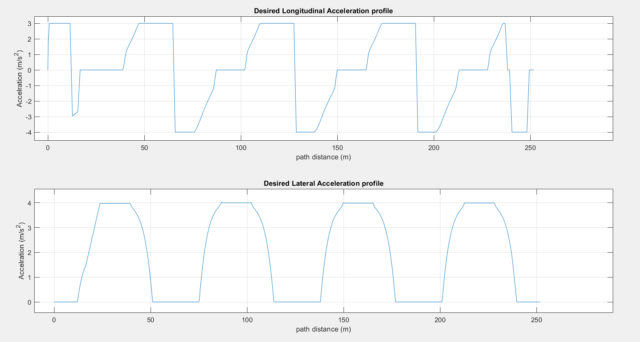

Figure 2.1. *Generated Desired Acceleration profile*

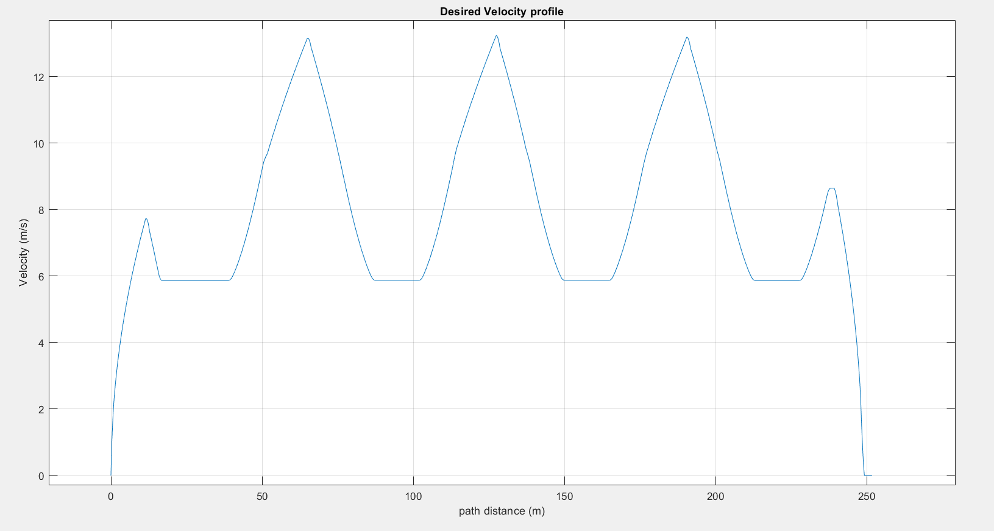

Figure 2.2. *Generated Desired Velocity profile*

The above velocity and acceleration profiles were generated considering the acceleration and deceleration constraints for the track and the specific velocities required at the start and end of the profile. The velocity profile for the turns was generated with the assumption that the car wil track an intermediate clothoid path profile generated at the intersection of the straights and turns. The maximum longitudinal velocity around the curves is dictated by the maximum acceleration permissible around the turns.

To ensure that the car enters this curve at the maximum permissible velocity, the velocity profile along the clothoid is generated by reverse integrating the expression for change in lateral velocity with path distance along the clothoid and thus also providing the acceleration profile for the same by simple differentiation of the generated velocity profile. This velocity profile also gives us the maximum permissible entry velocity and expected exit lateral velocity for each clothoid. These entry and exit velocity values along with the maximum longitudinal acceleration and deceleration allow us to generate the speed and acceleration profile for the straights.

The profile deviates from this method of generating the velocity and acceleration profiles for the initial phase of the profile. For the initial section from the start to the first corner, a lower than maximum acceleration is assumed to ensure a smooth profile for the car starting from stand still. This was done as based on the calculations, it was observed that the car cannot reach the maximum permissible entry velocity and hence a slower velocity and therefore acceleration profile is assumed for the initial section

**3. Look ahead controller - Simulation, Experiment and Error sources**

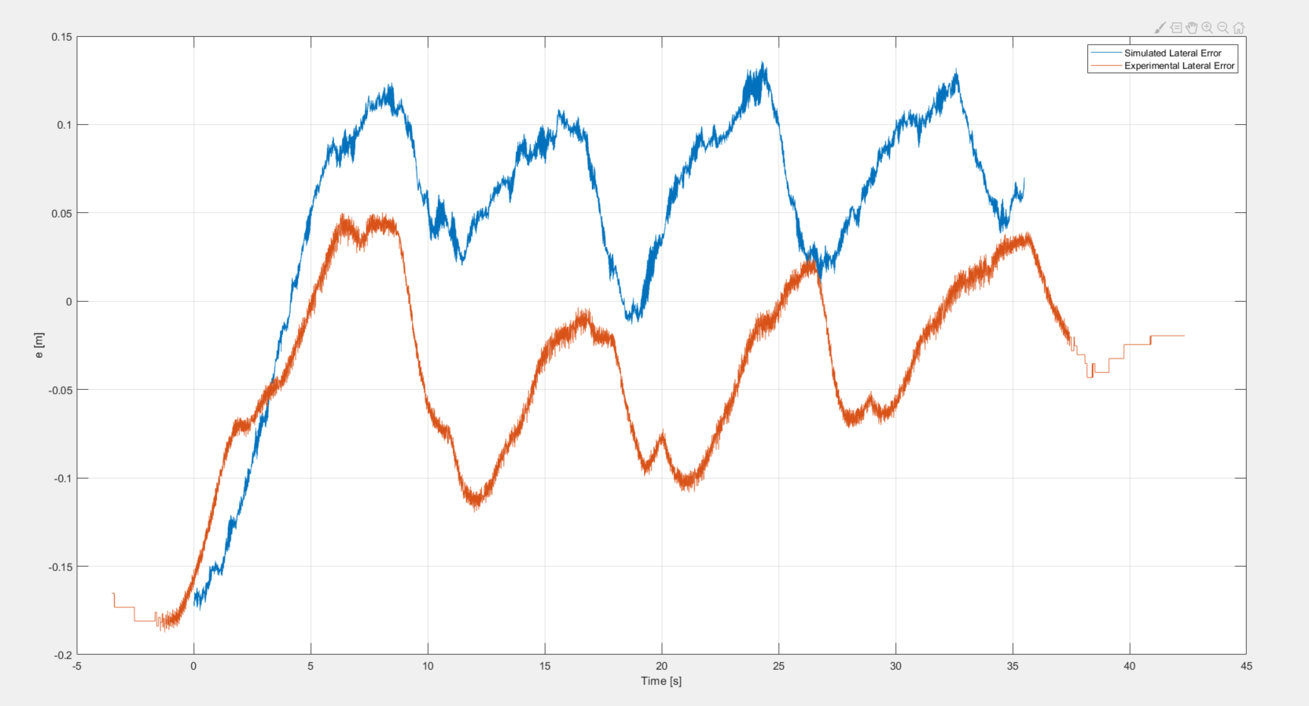

Figure 3.1. *Simulated and Experimental lateral error data for the experiment*

The actual lateral error when compared to the simulated error is offset and goes negative on the straights. The maximum lateral error was 0.05m which was well below the desired error spec of 0.3m. The parameters used or the lookahead controller are as follows -

The first hypothesis made was the increase in mass of the vehicle due to additional weight of the passengers which would slow down the response of the system compared to the simulation.

Another was the delay in the longitudinal force. The actual force on the car would be lagging behind the force commanded by the controller due to the additional dynamics of the system.

Both these hypotheses are discussed in detail in the following sections

**3.1 Parameter Error**

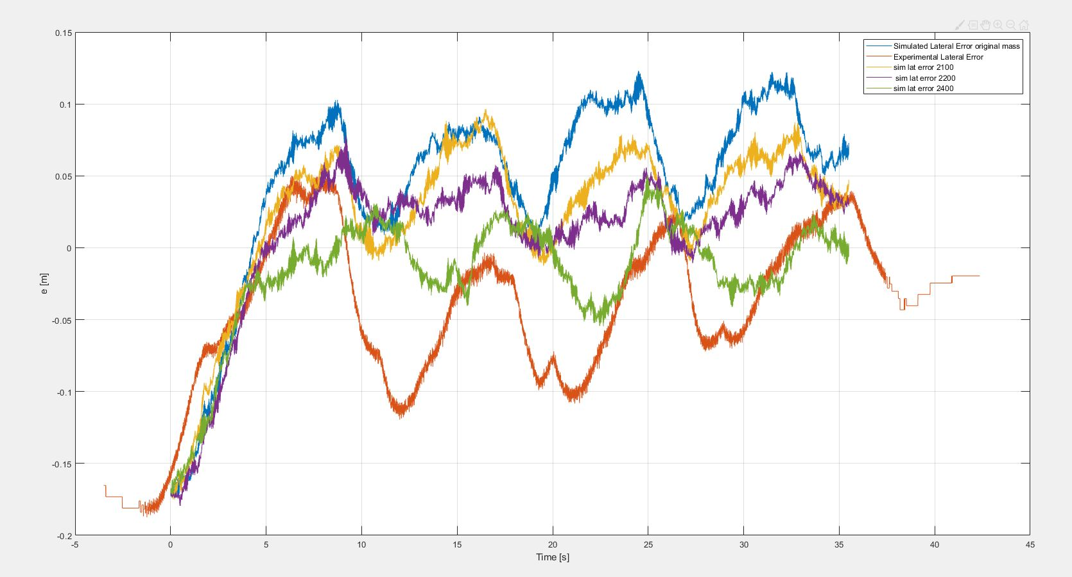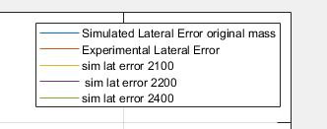

Figure 3.1.1. *Changes observed in lateral error due to change is vehicle mass*

The simulation assumes that the parameters of the system are accurate and constant. However, certain parameters can be expected to change. A few of those are - weight and weight distribution (due to the weight of the 4 passengers), change in and tire stiffness (due to change in road/tire conditions). It can be argued that the change in mass is inevitable, therefore the team decided to check if it's signature was visible in the actual lateral error curve.

In the above graph, the lateral error was plotted at increasing weights of the vehicle. This was done to simulate the additional weight of passengers that was not accounted for during simulation. The lateral error keeps getting more and more negative and we see more lag in the response also. This is similar to the actual data where the lateral error goes negative on the straights.

**3.2 Unmodeled Dynamics and Delay**

The acceleration and braking responses in our simulation were very fast, but we expected the responses in actual experiments to differ from simulation because the dynamic responses of the vehicle are not as fast as we might expect in simulation.

There can be many reasons for the delayed response like, hydraulic delays in actuating brakes or suspensions; air intake delays due to opening and closing of valves in an IC engine or delayed response of steering due to mechanical friction between the gears and the steering mechanism. Even though these delays are small in terms of dynamics, these result in identifiable time delays observed with the sensors we have.

**3.2.1 Observation of Delay in Experimental Data**

To start with our analysis; we plotted the Commanded Experimental Force and the observed Force which the car experienced as F = m.ax. The plot below identifies this behavior:

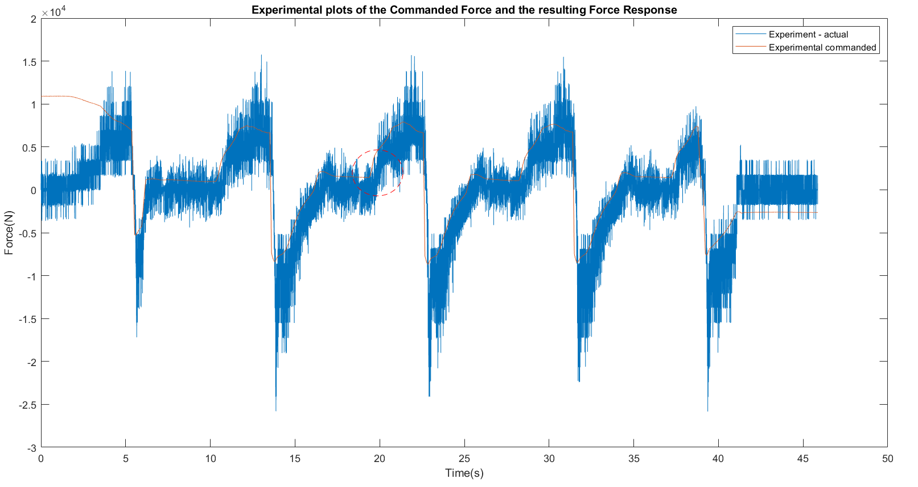

Figure 3.2.1. *The above plot shows the delay in actual experimental response*

We used the encircled region in red dashes to obtain the time constant for the delayed response. Moreover, we can observe that the accelerating region is slower than the braking region; showing that engine delay is greater than braking delay.

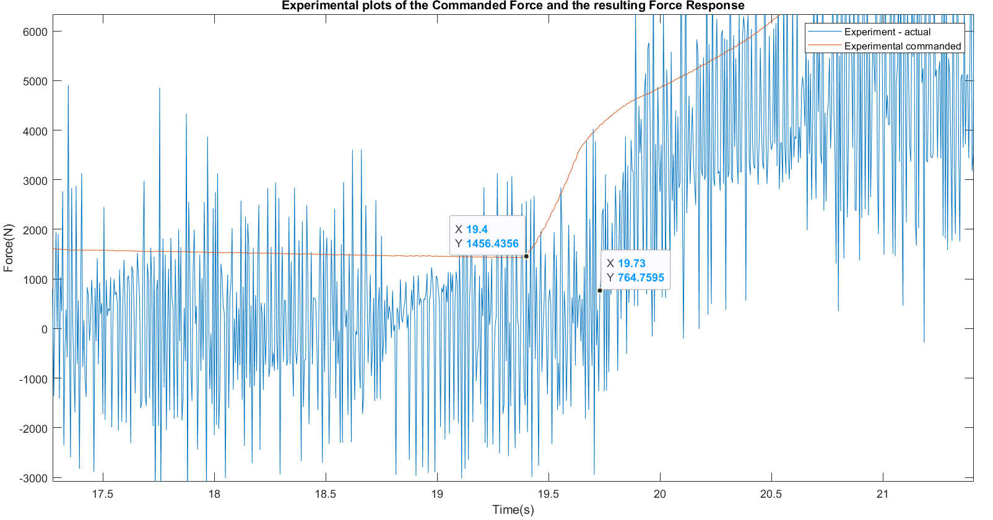

Figure 3.2.2. *Calculating the time constant from the observed delay*

Based on the observed delay between command and response we observed our time constant to be roughly ~

**3.2.2 First Order Dynamics in Longitudinal Force**

Equipped with the time constant we acquired, we set off to add simple first order dynamics between desired value of longitudinal force and the actual value as suggested in the Report description as per the equation:

So, we added the proposed state in our code and simulated the desired and actual value for the longitudinal force and observed similar behavior in our simulations for delay as observed in real data.

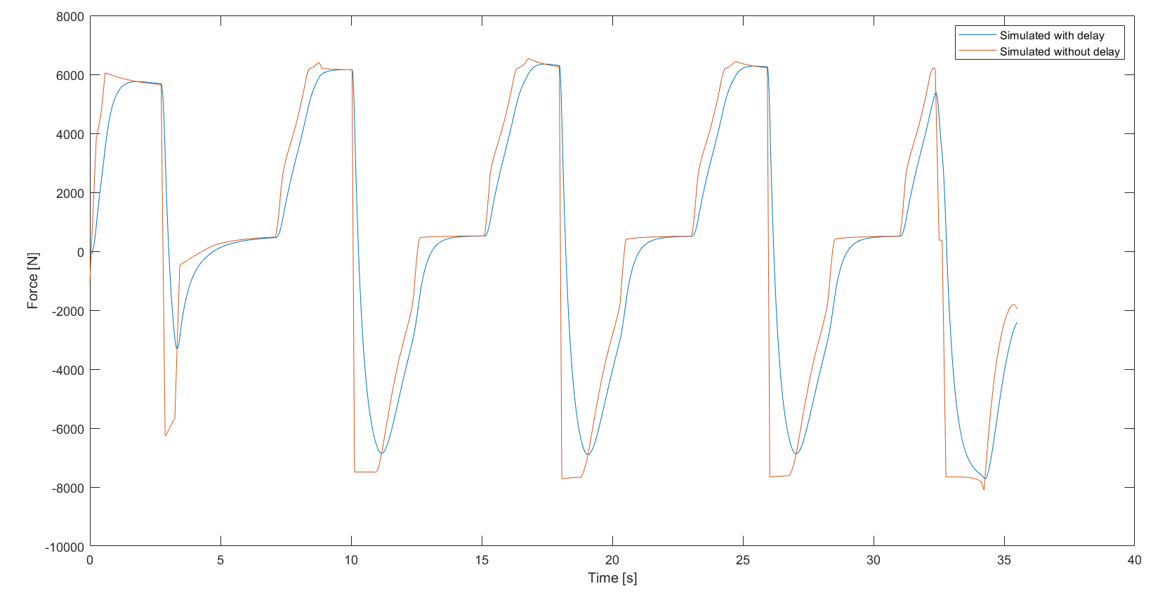

Figure 3.2.3. *Simulated response including the first order dynamics*

We also plotted the accelerations obtained from the simulation without delay and the one with delay to observe the effect of dynamics of acceleration and braking.

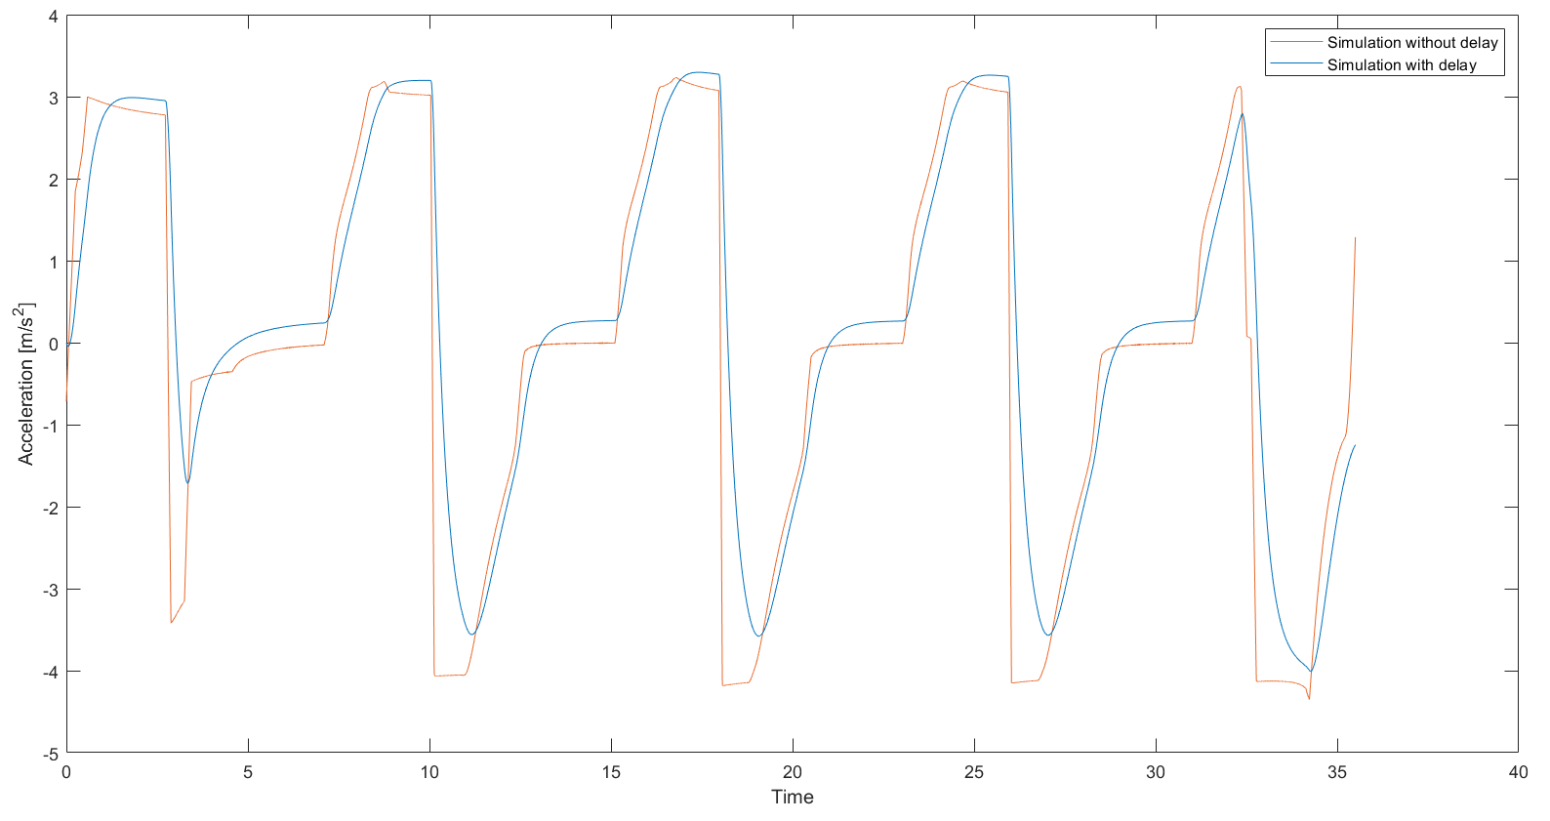

Figure 3.2.4. *Longitudinal acceleration comparison (with and without delay)*

However, these conclusions were drawn for time constant derived from the acceleration profile. So, we also tried to model the dynamics for the braking profile. As shown in the plots below; we computed the time constant for braking and observed its effects in simulation:

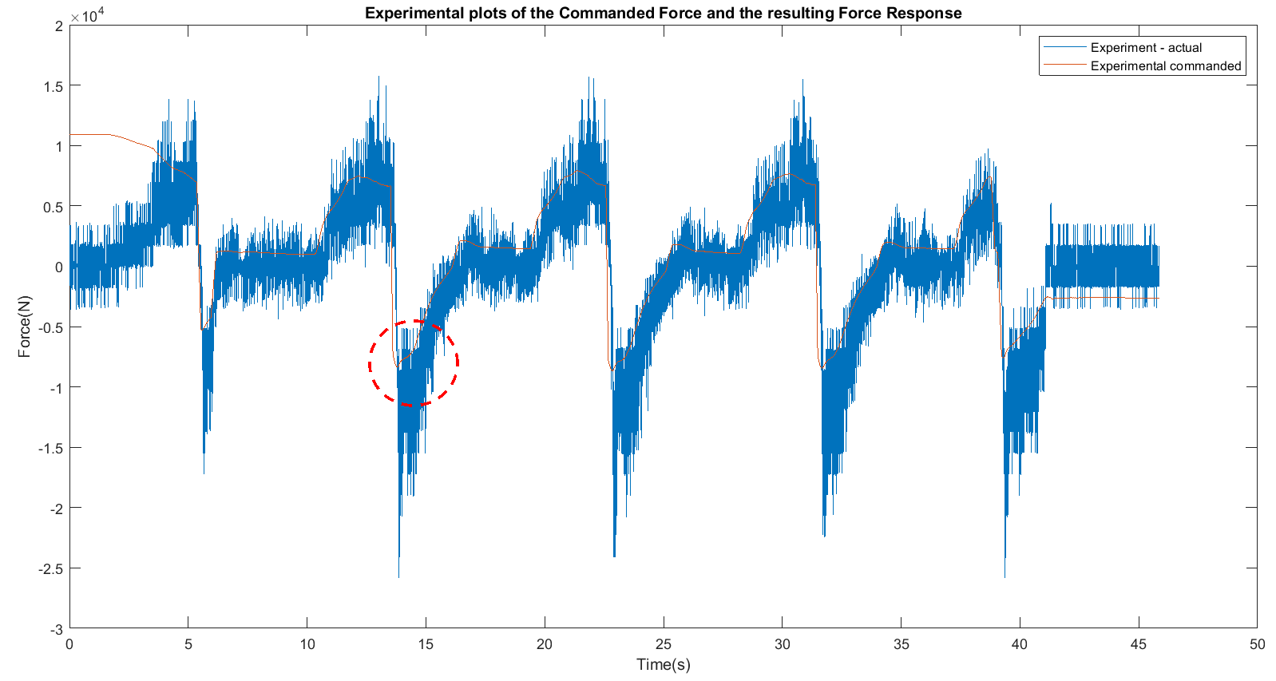

Figure 3.2.5. *The above plot shows the delay in actual experimental response for braking*

We used the encircled region in red dashes to obtain the time constant for the delayed response in braking.

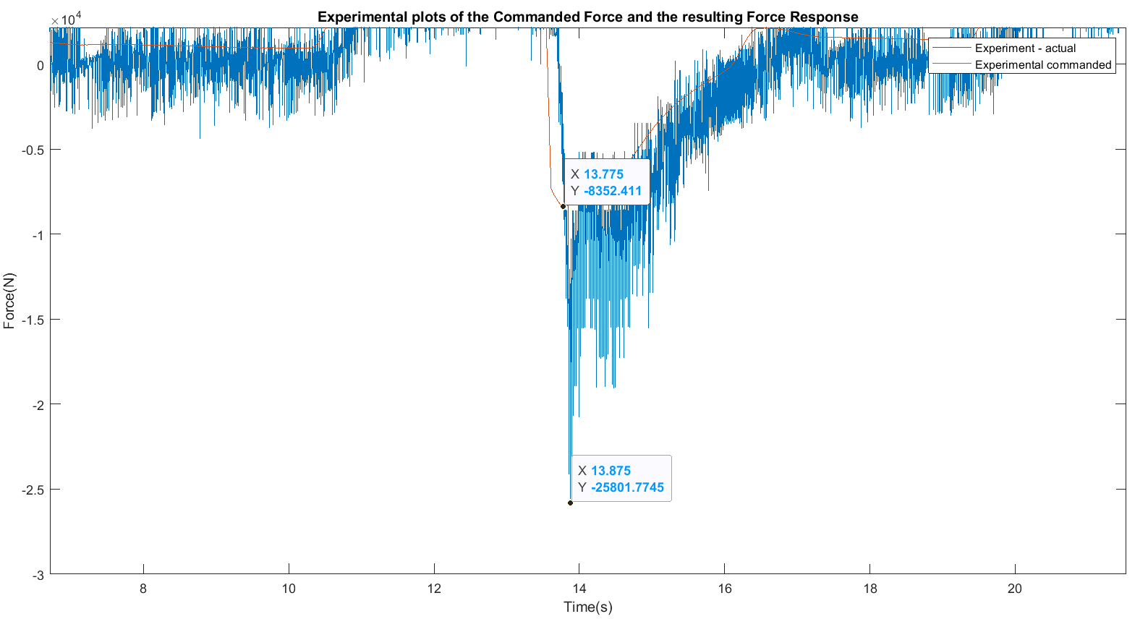

Figure 3.2.6. *Calculating the time constant from the observed delay for braking*

Based on the observed delay between command and response we observed our time constant to be roughly ~ for braking.

We accounted for this time constant and again plotted our simulated response with delay to observe acceleration plots for braking section.

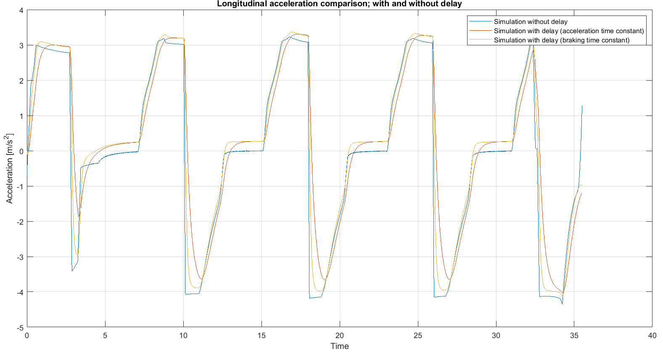

Figure 3.2.7. *Longitudinal acceleration comparison (with and without delay) for braking*

It can be observed from the above figure that for the lowe parts of the graph (below zero) where braking takes place; the plots modelled with time constant for the braking section show faster response than that modelled with the time constant for accelerating section. This reinforces our hypothesis of braking response to be faster than engine acceleration response.

Thus, we observed that unmodeled dynamics introduce delays between simulated and actual responses. Adding a first order dynamical model helped us to identify these delays.

**4. Controller Comparison**

**Parameters for Look ahead Controller**

(Longitudinal controller gain)

**Parameters for LQR based Controller**

(Longitudinal controller gain)

**4.1 Observed parameter plots**

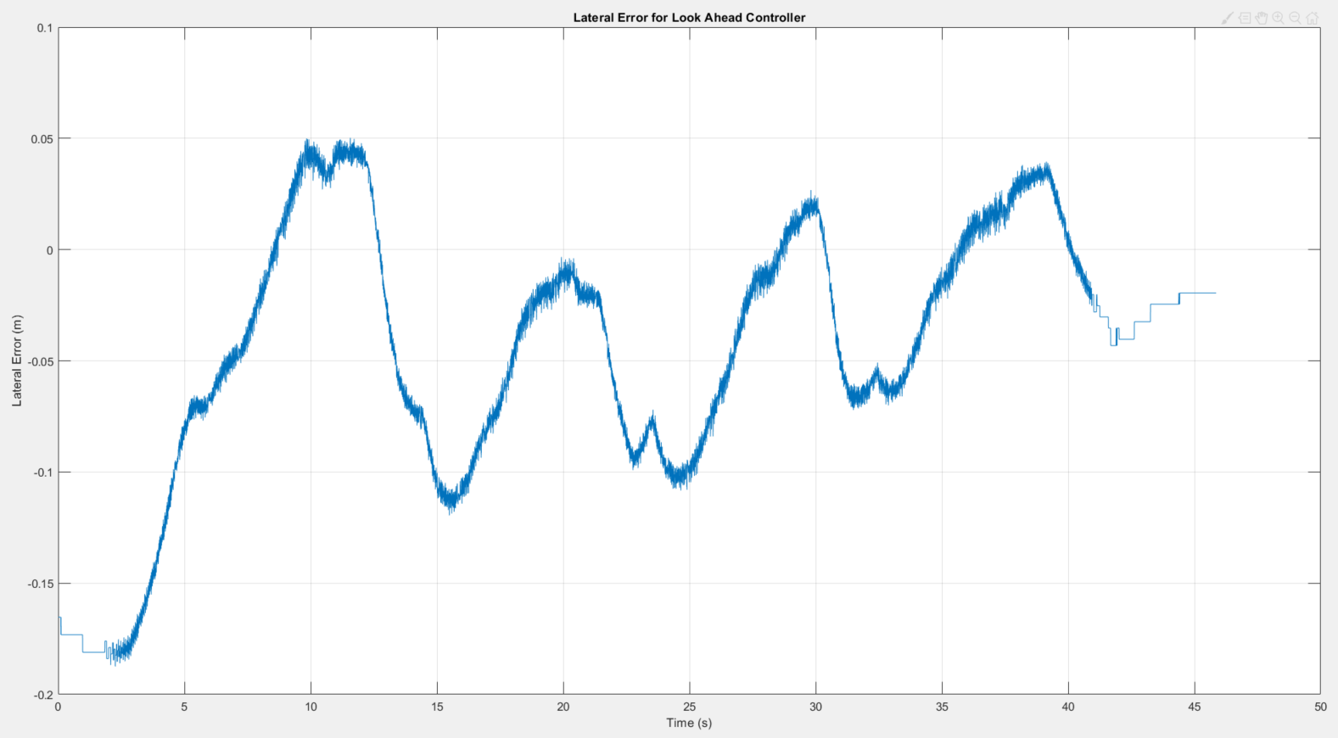

Figure 4.1. *Lateral errors observed for Look ahead controller*

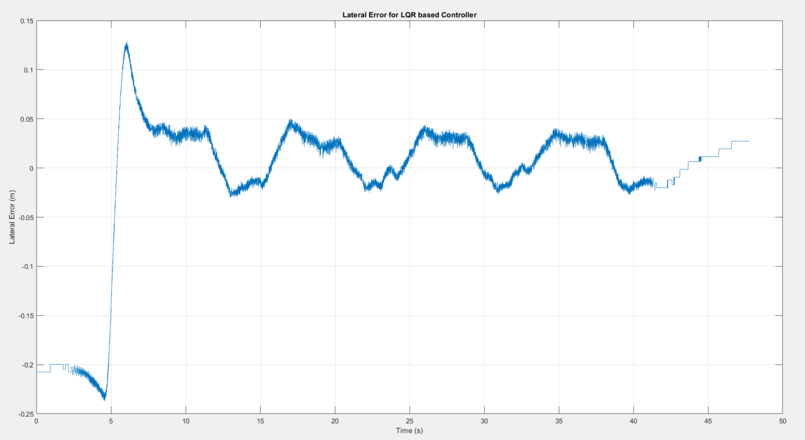

Figure 4.2. *Lateral errors observed for LQR controller*

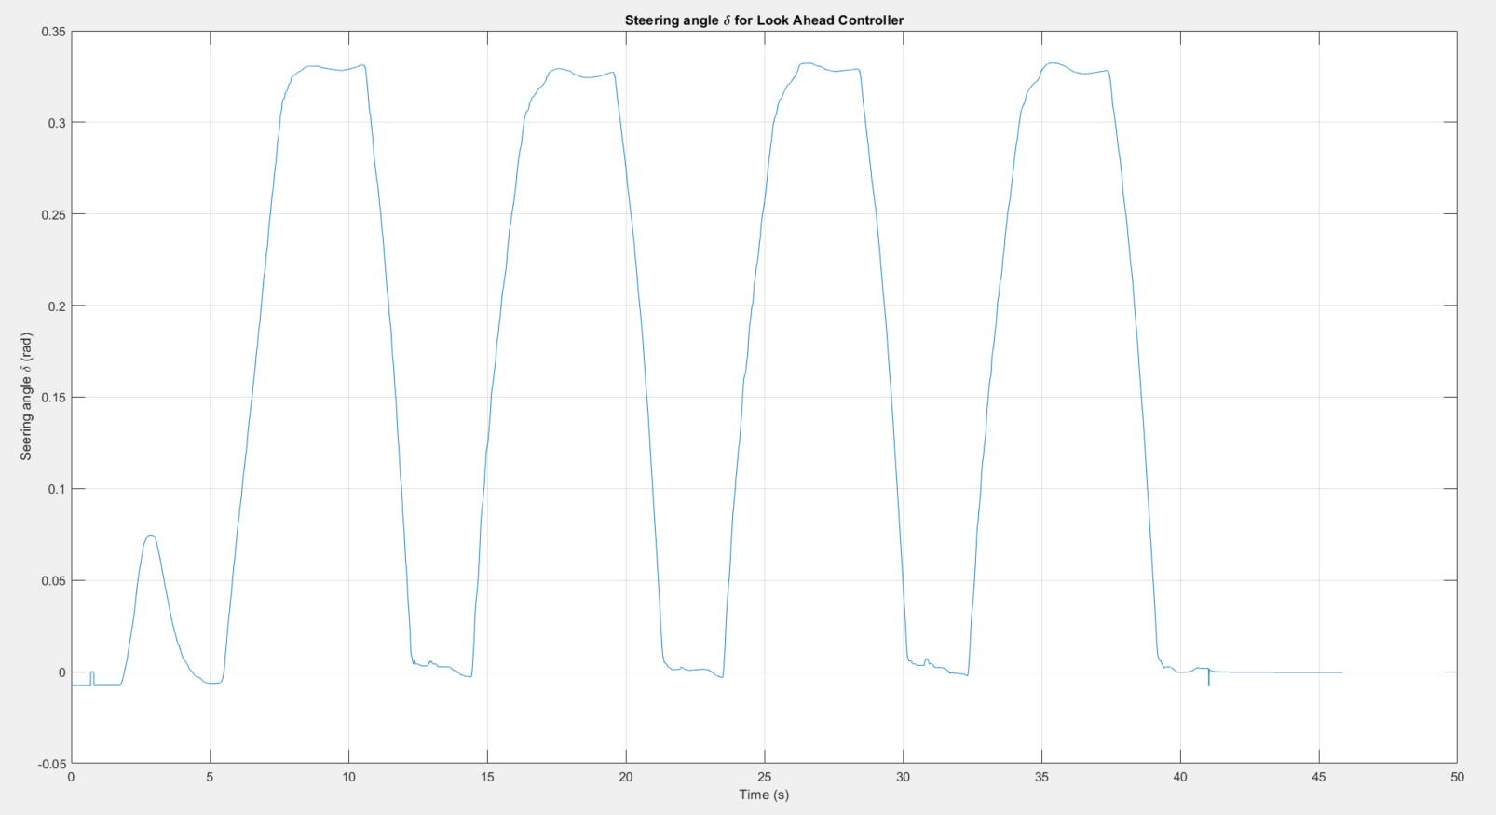

Figure 4.3. *Steering angles observed for Look ahead controller*

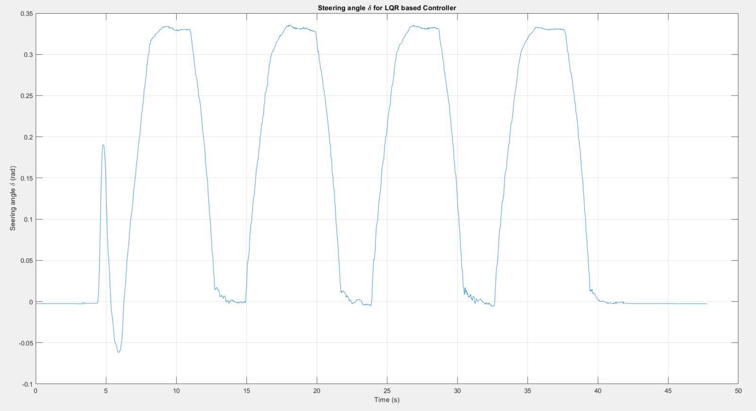

Figure 4.4. *Steering angles observed for LQR controller*

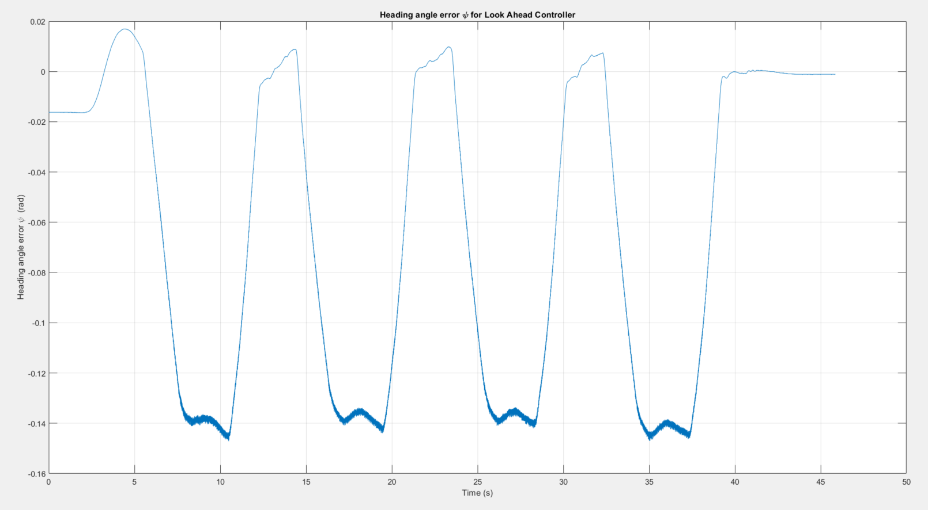

Figure 4.5. *Heading errors observed for Look ahead controller*

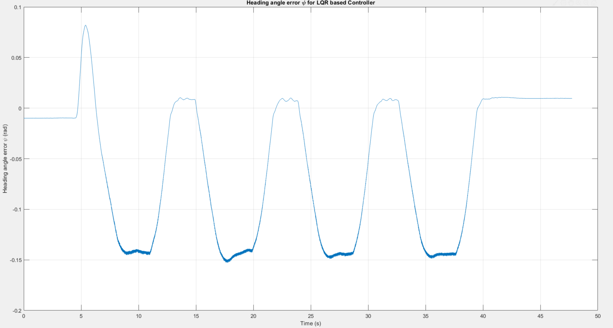

Figure 4.6. *Heading errors observed for LQR controller*

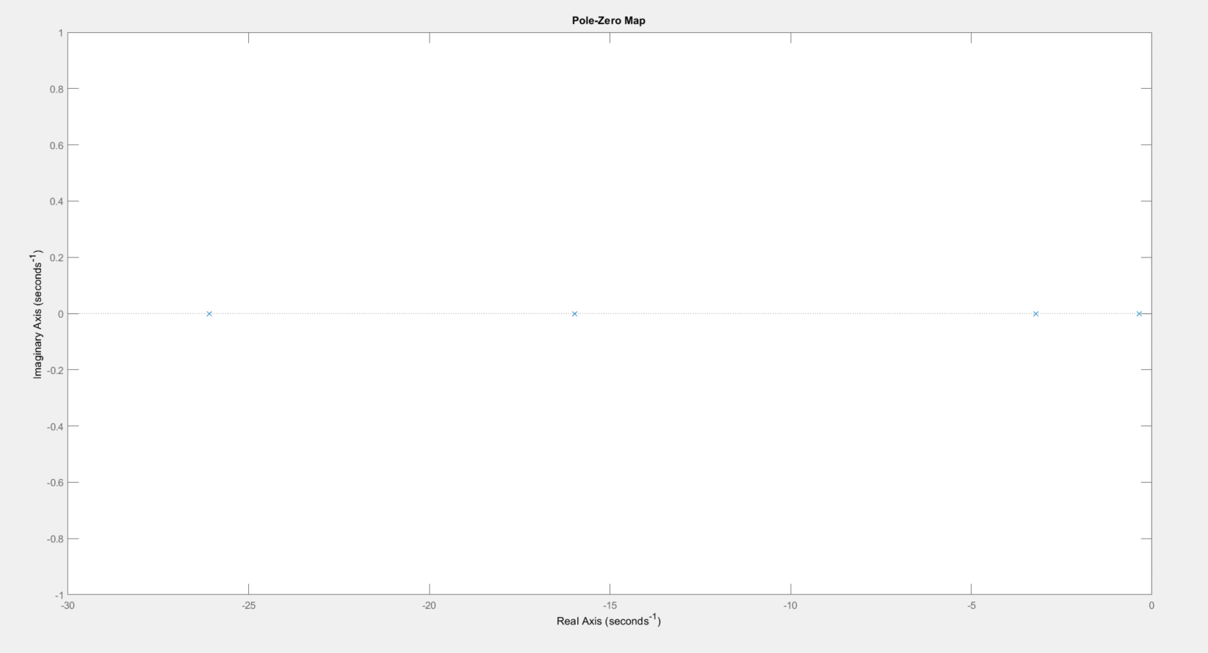

Figure 4.7. *Pole Zero mapping for Look ahead controller*

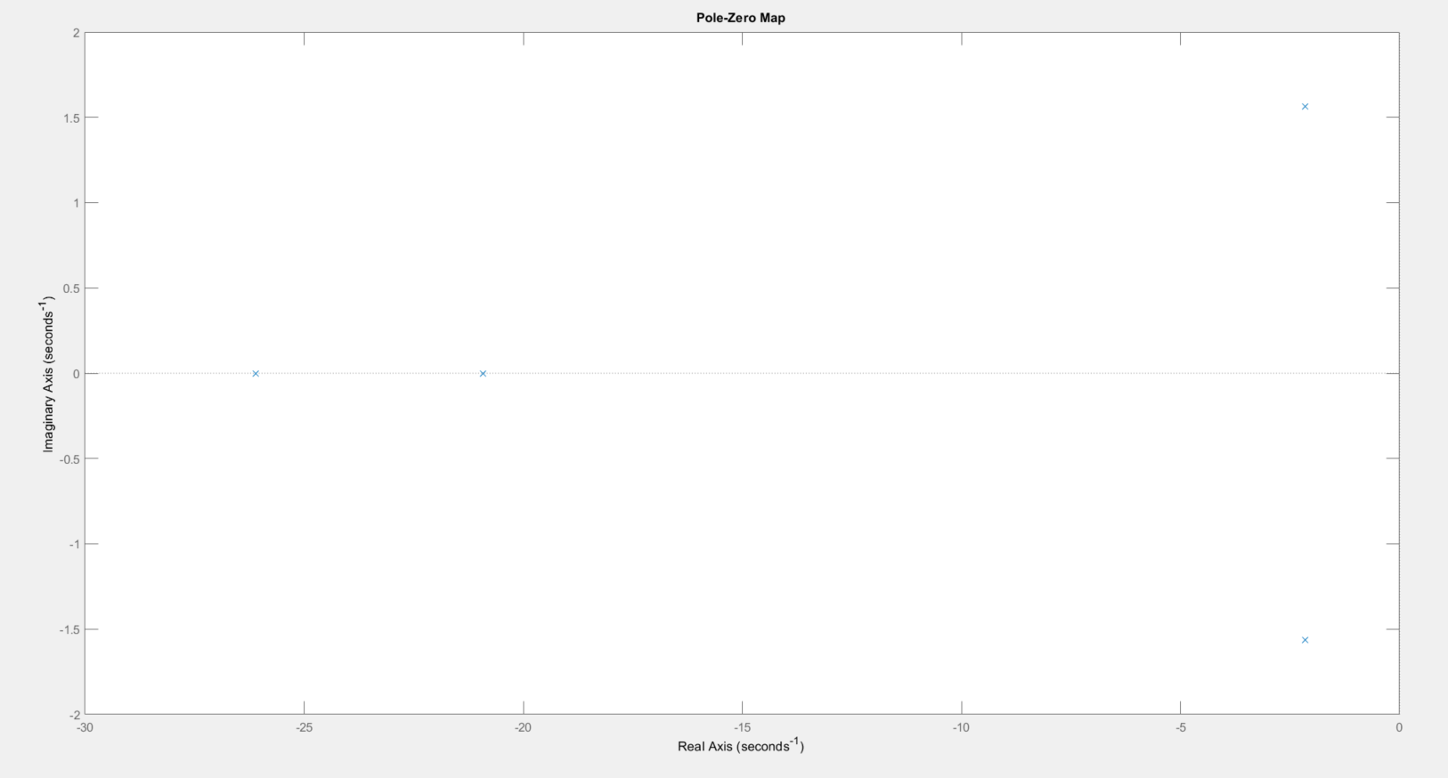

Figure 4.8. *Pole Zero mapping for LQR controller*

**4.2 Performance and Noise comparison**

**4.2.1 Observed performance**

Observing the plots for the lateral errors for produced when both controllers are used respectively, it can be seen that the Lookahead controller is slower to respond to the error as compared to the LQR based lateral controller.

This sluggish response of the lookahead controller is further responsible for the larger lateral errors created while tracking the desired path when compared to the faster response and subsequently lower lateral errors seen for the LQR based controller. This behaviour can be justified by observing the above pole zero plots. The dominant poles of the Lookahead controller are critically damped and are closer to the origin, hence verifying the well damped but often sluggish response of the controller to lateral errors, while the dominant pair of poles of the LQR based controller lie on the imaginary right half plane of the s plane, hence verifying the faster response of the LQR controller to lateral errors.

Also to be noted, the while one of the non dominant poles of both the controllers are in the same location, the remaining pole of the controllers are critically damped but the pole of the LQR controller is further to the left, hence contributing to the faster response of the controller. A quick look at the heading angle error shows the fact that the lookahead controller does achieve near zero heading angle error while the LQR based controller does have a slight heading error, which is negligible. This is again justified by the formulation for the controllers : Lookahead working on the the heading and lateral errors while the LQR controller penalizes the lateral error and its derivative, while ignoring a penalty on the heading error and its derivative in its formulation. This was deliberately done as the turns on the track require the heading error to be non zero.

**4.2.2 Observed Noise**

Observing the plots for the steering angle signal provided by the controllers, it can be seen that, though minute, the noise in steering angle output for the LQR based controller is higher than that observed for the Look ahead controller. This can be justified by the fact that for Look ahead controller the lateral and heading errors are the only states that could be affected by sensor noise whereas for the LQR based controller, the steering angle output is produced applying the gain to all four of the error states observed, each of which is susceptible to sensor noise. The noise propagation from all four states is higher than just the lateral and heading error noises alone, hence resulting in the observed noisier steering angle output from the LQR based controller as compared to the Look ahead controller.